Leaf Area Expansion and Senescence Simulation in MAIZSIM

Soo-Hyung Kim, Univ. of Washington and Dennis Timlin, USDA-ARS

In MAIZSIM, leaf area is simulated by tracking growth and senescence of individual leaves as detailed in Kim et al. . Individual leaf growth is tightly linked to leaf initiation and appearance rates in the phenology module. Individual leaf size is determined using a bell shaped distribution function with respect to the largest leaf size according to Fournier and Andrieu (1998), and leaf growth and senescence functions have been adopted from Lizaso et al. .

Briefly, the hourly rate of increase for the area of a single leaf is calculated using a logistic growth function from Lizaso et al., (2003).

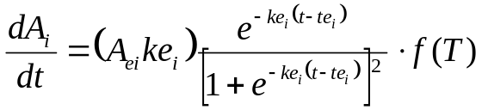 | [1]

The leaf growth rate is a function of growing degree days (t) after emergence with base temperature of 8 ºC (GDD_{8C}). Where Ae_{i} is the potential leaf area (cm²) of leaf with rank i, te_{i} the thermal time (GDD_{8C} after emergence) when the leaf reaches 50% of its final area, and ke_{i} is a unitless parameter controlling the slope of the curve (aka intrinsic growth rate). The final leaf area at each nodal unit is determined based on its rank relative to the rank and area of the largest leaf (Ae_{m}), and total leaf numbers determined in the phenology module (Fournier and Andrieu, 1998; Birch et al., 1998). The basic structure of this model (Eq. [1]) as used in Lizaso et al. (2003) is maintained in MAIZSIM with modifications to account for the temperature effects on final leaf area (Ae), intrinsic growth rate (ke), and the thermal time (GDD_{8C}) at 50% leaf area (te) described below.
Leaf longevity (based on GDD_{8C}) is also calculated as in Lizaso et al. (2003). Leaf senescence is considered to be a negative growth resulting in a decrease of current leaf area. It is calculated using an equation similar to Eq. [1] assuming that the rate for leaf senescence is a half of that for growth. The original parameters and equations were retained for this relationship. There were no cardinal temperature adjustments in the senescence relationships.

Temperature dependence of leaf expansion parameters
The parameters (Ae, ke, and te) in Eq. [1] were modeled to respond to cardinal growth temperature. Several studies have shown that total plant leaf area as well as individual leaf size responds to temperature in a nonlinear fashion . This effect of temperature on final leaf size (Ae) is modeled using a peaked exponential function given in Eq. [2].

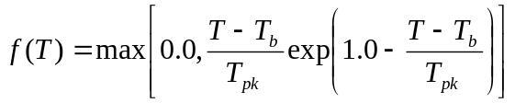 | [2]

Where T is the air temperature, T_{pk} is the peak temperature at which this function (f(T)) reaches the maximum value (=1.0). In our model, f(T) scales hourly leaf expansion rate (Eq. [2]) in proportion to the potential final leaf size at rank i (Ae_{i}) as a function of current growth temperature. Starting from zero at T_{b}, this function rapidly rises to reach the maximum at T_{pk} then gradually declines with increasing temperature (see Fig. 1a).

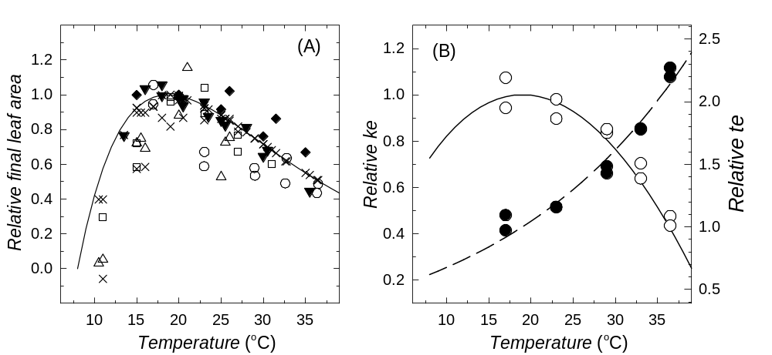
Figure 1. Temperature dependence of relative final leaf area (Ae), intrinsic leaf growth rate (ke), and the inflection point at which 50% leaf expansion occurs (te) in the leaf growth model as described in Eq. [1]. (A) Relative final leaf area as a function of growth temperature (Eq. [2]). Symbols represent relative final leaf area reported in the literature for whole-plant ( Kim et al., 2007;  Boss et al., 2000;  Tollenaar, 1989) or individual leaves ( Hesketh and Warrington, 1989;  Fournier and Andrieu, 1998). Model predictions accounting for day/night temperature differences () and using daily mean temperatures (solid line) are also shown. (B) Relative ke () and temperature scaling factor for te () from Kim et al. (2007) compared with model ke (solid line) and modeled scaling factor for te (dashed line) described in Eq. [3] and [4]. This figure is adopted from Kim et al. (2012)

The base temperature (T_{b}) of 8 ºC has been applied here. Thus this function describes no leaf expansion at or below 8 ºC. The peak temperature (T_{pk}) of 18.7 ºC has been determined based on reported data in the literature (Figure 1).
The temperature dependence of the intrinsic growth rate parameter, ke_{i}, was modeled using a reduced beta function (Yan and Hunt, 1999) in response to air temperature as follows.

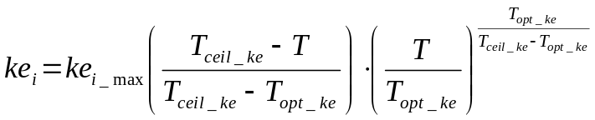 | [3]

T_{opt_ke} is the optimal temperature at which the maximal intrinsic growth rate (ke_{i} = ke_{i}__{max}) is achieved and T_{ceil_ke} is the ceiling temperature at which leaf growth ceases (ke_{i} =0).
We found that T_{opt_ke} is virtually identical to T_{pk} determined for Eq. [2] (Kim et al., 2012). In practice, T_{opt_ke} is set to T_{pk}.

Similarly, the temperature dependence of GDD required for 50% leaf expansion (t_{e}) in Eq. [1] is adjusted in response to air temperature by h(T):
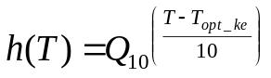 | [4]

Where Q₁₀ is a parameter that controls the rate of change of te with temperature. This function is scaled to 1.0 when air temperature (T) is equal to T_{opt_ke} (and thus T_{pk}) which is the optimum temperature at which the ke_{i}__{max} is observed.
The above relationships characterize the nonlinear dependence of three leaf expansion parameters (Ae, te,, and ke) on air temperatures and to augment the leaf expansion model as a function of GDD with nonlinear temperature response. In practice, leaf size increment at each time step (i.e., dAe_{i}/dt in Eq. [1]) is adjusted to respond to hourly growth temperature by multiplying a peaked exponential function (Eq. [2]) to the potential leaf size (Ae_{i}) achievable for the temperature. Both ke_{i} and te_{i} are also adjusted to respond to hourly growth temperature using Eq. [3] and Eq. [4], respectively.

References

Bos, H.J., Tijani-Eniola, H. and Struik, P.C., 2000. Morphological analysis of leaf growth of maize: responses to temperature and light intensity. Netherlands Journal of Agricultural Science, 48(2): 181-198.
Fournier, C. and Andrieu, B., 1998. A 3D architectural and process-based model of maize development. Annals of Botany, 81(2): 233-250.
Hesketh, J.D. and Warrington, I.J., 1989. Corn growth response to temperature - Rate and duration of leaf growth. Agronomy Journal, 81(4): 696-701.
Kim, S.-H. et al., 2007. Temperature dependence of growth, development, and photosynthesis in maize under elevated CO₂. Environmental and Experimental Botany, 61(3): 224-236.
Kim, S.H. et al., 2012. Modeling temperature responses of leaf growth, development, and biomass in maize with MAIZSIM. Agronomy Journal, 104(6): 1523-1537.
Lizaso, J.I., Batchelor, W.D. and Westgate, M.E., 2003. A leaf area model to simulate cultivar-specific expansion and senescence of maize leaves. Field Crops Research, 80(1): 1-17.
Tollenaar, M., 1989. Response of dry matter accumulation in maize to temperature: I. Dry matter partitioning. Crop Science, 29: 1239-1246.

